11 7 WA S H I N G TO N S P R I N G R O A D, PA L I S A D E S, N Y 1 0 9 6 4 № APRIL 2017

PAL PRES
Pal Pres
Palisades Presbyterian Church
A Monthly Publication

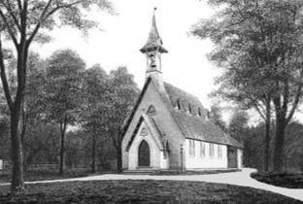
Easter Services

We are hosting the traditional joint potluck dinner and tenebrae service with St. Charles AME Zion Church on Maundy Thursday this year. The potluck dinner is scheduled to begin at 6:30 pm and the service will start at 8:00 pm.

An Ecumenical Good Friday Service, involving all the local congregations, is to be held at Christ Episcopal Church in Sparkill, time to be announced.

Our Easter Sunrise Service will again take place at the home of Nick and Cass Ludington at 6:30 am Easter Morning. It will be followed by a potluck breakfast. Easter Service at the church will be held at 10:00 am followed by the annual Easter Egg Hunt at 11:00 am. All children are welcome to participate.

transforming our hearts. This is indeed holy.
God, however, cannot do it alone. God respects our freedom and our choices. Can we, in this Easter season allow God to transform our lives? Can we let go of our pain, our resentments, our grudges and any other addictions we have to the energy of the darkness? This is the question before us. The answer is we cannot; not at least without God’s help and grace.
As Lent becomes Easter, may we pray to be released from the hardness of heart toward ourselves and toward anything that separates us from the love of God, so that we may experience the joy of new life promised to us in the Resurrection.
May we indeed embrace the holiness of our nights.

Blessings,
Angela

― REFLECTIONS ―

“Holy darkness, blessed night,
Heaven’s answer hidden from our sight.
As we await you, O God of silence,
We embrace your holy night.”
-Dan Schutte

“Holy darkness.” I never thought of darkness as being holy before. Yet this idea based on the writing of St. John of the Cross, a mystic who lived in the 16th century C.E., encourages us to embrace the darkness of our lives for it is here we encounter God.
This is indeed the promise of the resurrection. No matter what may be happening in our lives, no matter what “dark night of the soul” we are experiencing, God is with us, transforming the night into day.
This is not a sentimentality that diminishes the pain we may be encountering. On the contrary, this idea recognizes that suffering is part of our human condition. It validates our experience while at the same time frees us from being in bondage to it. This is the power of the Jesus’ story: his life, death and resurrection.
What a wonderful idea to think of God, who by God’s very being is beyond human understanding, becomes human. This Deity so desired to be in relationship with humanity that God became human in the man Jesus; not to initiate some cosmic justice of avenging God’s honor, or ransoming humanity from the devil; not to exact cosmic retribution, but to be in solidary with creation, all of creation.
God became human to be one with humanity and forever become part of every aspect of the human condition, its joy and sorrows.
The Resurrection is God’s ultimate redemption of whatever we are experiencing in our lives. It is the light shining in the darkness, the glimmer of hope and new life we intuit when we feel as if we are being overcome by sadness. It is what helps us breath when we cannot find our breath. Resurrection is the promise that there is no suffering separate or foreign to God’s experience and so God shares our pain, our sorrows and our suffering ultimately creating new life from the darkness,
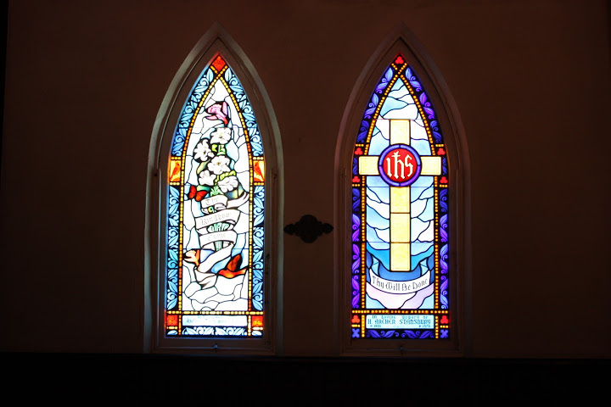
Save the Date
On May 21, following the worship service, a reception will be held to celebrate the restoration of the stained glass windows in the sanctuary and to thank those who supported this project. A presentation will be made by Stephen Van Dyk about the history of the windows and a representative from Willett-Hauser will talk about the work that was done to restore them.

APRIL CALENDAR

Sunday Worship 10:00 am

Bible Study Wednesdays 12:15 pm

April 2 Communion
Meatball-making prep for Spaghetti Dinner, 10:00 am
April 4 Session, 7:30 pm
April 9 Palm Sunday
Fish Boxes collected for OGHS
April 13 Maundy Thursday potluck dinner, 6:30 pm
Maundy Thursday service, 8:00 pm
April 16 Sunrise Service at the Ludington's, 6:30 am
Easter Service, 10:00 am
Easter Egg Hunt, 11:00 am
April 21 Spaghetti Dinner, 5:30 – 7:30 pm
April 30 Hospice Walk to Remember, 8:00 am at
Rockland State Park, North Entrance
Helping Hands Forum, 4:00 pm

Helping Hands Forum
On April 30 at 4:00 pm the Palisades Presbyterian Church will hold a community forum with Helping Hands for the Homeless of Rockland. The Church wishes to participate in their Safe Haven program next winter, along with dozens of other churches, offering a few nights of food and housing to those in our county who are struggling to find shelter during the cold months. Come learn more about this wonderful program, the plight of the homeless, the need for shelter in Rockland and how vital it is for all of us to lend a 'helping hand'.
We hope many community members will join us in organizing dinner meals and basic supplies for guests who participate.

Easter Lilies
We are accepting donations for lilies in memory of those we have lost. The lilies will decorate the Sanctuary for Easter and then be distributed by the Deacons to members and friends who have suffered a loss or an illness. Each lily donation is just $10. Forms are available at the Church office or in the Sunday bulletin. Please return forms by April 9.
Thank you for your contribution.

Spaghetti Dinner

Brought to you by the children of the
Palisades Presbyterian Church
to benefit United Hospice of Rockland

Saturday, April 21, 5:30 pm – 7:30 pm

$8.00 Adults
$5.00 Children 12 & under
$20 Family Maximum

Spaghetti & Meatballs
Salad & Bread
Dessert

Deacons’ Corner

Not much news from this corner except that we're all glad to have made it through the late blizzard this year!
Our church is hosting members of St. Charles AME Zion Church on Maundy Thursday and we would appreciate any food donations for the potluck at 6:30 pm.
Everyone is looking forward to a happy Easter Sunday.
All else stays the same: for rides call Jim Rubenstone, for prayer requests call Stephen Van Dyk, for casseroles contact Margaret Allen and for questions or other Deacon related concerns call Denise Cae Tilberis. Happy Easter to all!

Pastor Reverend Angela Maddalone * pastorajm@gmail.com * 845-359-3147 * www.palpresny.org
Secretary Tamika Adjemian * Office Hours Tuesday & Thursday 9:30 am – 2:30 pm * ppc10964@gmail.com Mailing address: Palisades Presbyterian Church, PO Box 687, Palisades, NY 10964
Articles due by the 20th day of the preceding month * Editor Maria Gagliardi * palpresny10964@gmail.com

